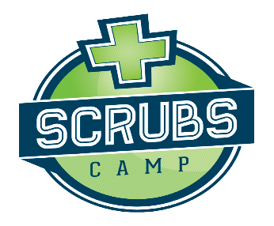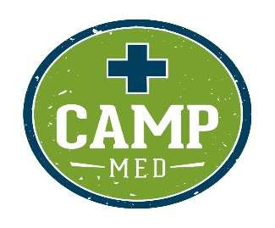

2022-2023 school year Scrubs Camp and Camp Med schedule as of 4-06-23

Fall 2022
09-22-2022 Watertown Scrubs Camp
10-05-2022 Huron Scrubs Camp
10-12-2022 Hot Springs Scrubs Camp
10-12-2022 Yankton Scrubs Camp
10-19-2022 Dell Rapids Camp Med
10-26-2022 Mitchell Scrubs Camp
10-28-2022 Winner Scrubs Camp
11-01-2022 Rapid City Scrubs Camp
11-03-2022 Pierre Scrubs Camp
11-04-2022 Aberdeen Camp Med
11-08-2022 Rapid City Camp Med
11-16-2022 Chamberlain Scrubs Camp
11-17-2022 Mobridge Scrubs Camp
12-14-2022 Sioux Falls (canceled due to weather)

Spring 2023
01-26-2023 Wagner Camp Med
02-02-23 Rapid City Area Schools Scrubs Camp
02-28-23 Beresford Camp Med
03-04-23 Custer Scrubs Camp
03-07-23 Vermillion Scrubs Camp
03-17-23 Spearfish Scrubs Camp
03-22-23 Pine Ridge Scrubs Camp
04-18-23 Madison Scrubs Camp
04-26-23 Freeman Scrubs Camp
04-26-23 Yankton Camp Med
05-10-23 Aberdeen Scrubs Camp
May 2&9, 2023 Chamberlain Camp Med
05-02-2023 Pierre Camp Med
05-09-2023 Parkston Camp Med
05-10-2023 Sioux Falls Scrubs Camp
5-11-23 Huron Camp Med
June 2023 Camp Med Sioux Falls

